Ex. No.: 6

Date:

SELECT with various clause – GROUP BY, HAVING, ORDER BY

1. Retrieve Name, Gender, Mobile No of all the students in ascending order of Reg No.

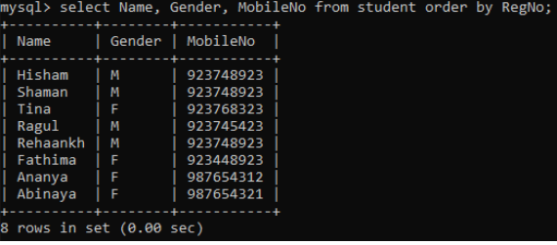

2. List the faculty members in the order of older faculty first.

